INPUT CSV FILE

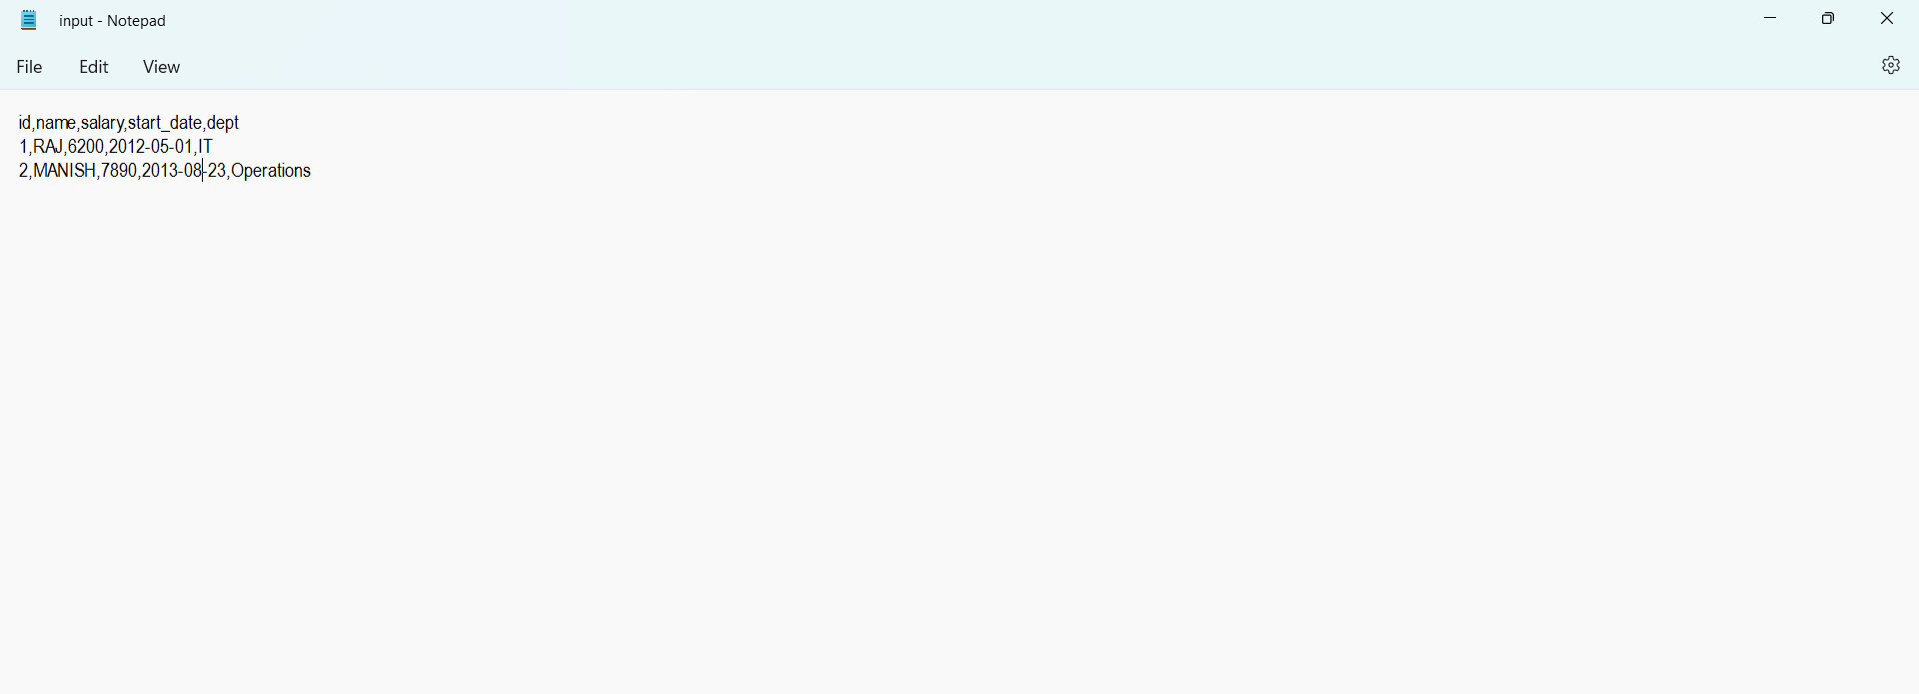

Highest salary

data <- read.csv("input.csv")

sal <- max(data$salary)

print(sal)